Partie1 : Essay

SQL Injection: A Persistent Threat to Database Security

In the modern digital age, databases form the backbone of countless applications, from e-commerce platforms to healthcare systems. As such, ensuring their integrity and security is critical. Among the most notorious and widespread vulnerabilities in database systems is SQL Injection (SQLi), a type of attack that exploits improper input handling in SQL queries. SQL Injection remains a relevant threat even after decades of awareness, underscoring the need for secure coding practices and robust defense mechanisms. This essay explores the concept, types, consequences, and preventive measures related to SQL Injection, along with real-world examples that highlight its potential damage.

I. Understanding SQL Injection

SQL Injection is a code injection technique where an attacker inserts malicious SQL statements into an input field of an application, which are then executed by the database server. These attacks typically exploit poorly sanitized or unsanitized user inputs embedded directly into SQL queries. For instance, consider the following insecure SQL query:

SELECT * FROM users WHERE username = 'admin' AND password = '1234';

If a user enters the input admin' -- for the username, the resulting query becomes:

SELECT * FROM users WHERE username = 'admin' --' AND password = '1234';

The -- sequence comments out the rest of the query, potentially allowing access without a valid password. Such attacks can bypass authentication mechanisms, read or modify sensitive data, or even delete entire databases.

II. Types of SQL Injection
SQL Injection is not a single, uniform technique; rather, it manifests in several variations:
- Classic/Union-Based SQLi: Utilizes the SQL UNION operator to combine malicious queries with the original. It allows attackers to retrieve data from other tables.
- Blind SQLi: When the application does not return error messages, attackers infer information by observing behavioral changes in the system. This can be:
  - Boolean-based: Injects conditional queries to see if a page behaves differently.
  - Time-based: Injects delays using functions like SLEEP() to infer data based on server response times.
- Error-Based SQLi: Relies on database error messages to reveal structure and data, often due to improperly handled exceptions.
- Out-of-Band SQLi: Utilizes alternate channels (like DNS or HTTP requests) to extract data when traditional in-band methods are not available.
Each method depends on how the application processes SQL commands and what feedback is provided to the attacker.

III. Consequences of SQL Injection
The implications of successful SQL Injection attacks can be severe:
- Unauthorized data access: Attackers can extract usernames, passwords, financial data, and other sensitive records.
- Data manipulation or deletion: SQLi can be used to insert, update, or delete data in the database.
- Privilege escalation: Attackers can potentially execute administrative operations or gain root acPartie 2 : Database Model Diagramcess.
- System compromise: In advanced attacks, operating system-level commands may be executed through the database.
Given these risks, SQL Injection has been ranked among the top vulnerabilities in web applications by the OWASP Foundation [2].

IV. Real-World Incidents
Numerous high-profile breaches have involved SQL Injection. In 2008, the Heartland Payment Systems breach exposed over 130 million credit card numbers, largely due to a successful SQLi exploit [1]. Another case involved Sony Pictures in 2011, where attackers used SQL Injection to access millionPartie 2 : Database Model Diagrams of user accounts [3]. These incidents underline the real-world impact of neglecting input validation and secure coding.

V. Prevention and Best Practices
Mitigating SQL Injection requires a combination of development discipline and security awareness:
- Use of Prepared Statements (Parameterized Queries): Instead of dynamically constructing SQL queries with user inputs, use placeholders to separate code from data. This is the most effective defense.

cursor.execute("SELECT * FROM users WHERE username = ? AND password = ?", (username, password))

- Input Validation and Sanitization: Reject or properly escape inputs that do not conform to expected formats.
- Least Privilege Principle: Database users should only have access rights necessary for their function.
- Regular Security Testing: Implement penetration testing and use tools like SQLMap to detect vulnerabilities.
- Web Application Firewalls (WAFs): Can help detect and block known attack patterns in real time.
By combining these measures, organizations can significantly reduce the risk of SQL Injection attacks.

VI. Conclusion
SQL Injection continues to be a critical threat in the realm of database security, largely due to inadequate input validation and insecure query handling. Despite being well-documented, many systems remain vulnerable, making it vital for developers and administrators to adopt best practices and proactive defense mechanisms. As databases continue to power essential applications, defending against SQL Injection is not just a technical requirement—it is a matter of trust and responsibility.

References
[1] W. G. Halfond, J. Viegas, and A. Orso, “A Classification of SQL-Injection Attacks and Countermeasures,” Proc. IEEE Int. Symp. Secure Softw. Eng., 2006.
[2] OWASP Foundation, “SQL Injection,” 2024. [Online]. Available: https://owasp.org/www-community/attacks/SQL_Injection

Partie 2 : Database Model Diagram

This section presents the Entity-Relationship Diagram (ERD) for an online store database. The model was created using the Python library Graphviz, following relational database design best practices.

1. Entities and Attributes
The database includes five main entities:
- Customers
  - customer_id (Primary Key)
  - first_name, last_name
  - email (unique)
  - password
  - created_at
- Products
  - product_id (Primary Key)
  - name
  - description
  - price
  - stock_quantity
- Orders
  - order_id (Primary Key)
  - customer_id (Foreign Key → Customers)
  - order_date
  - total_amount
- Order_Items
  - order_id (Primary Key, Foreign Key → Orders)
  - product_id (Primary Key, Foreign Key → Products)
  - quantity
  - price_each
- Payments
  - payment_id (Primary Key)
  - order_id (Foreign Key → Orders)
  - payment_date
  - amount
  - payment_method

2. Relationships Between Entities
- A customer can place multiple orders → 1:N between Customers and Orders.
- An order can contain multiple products, and each product can appear in multiple orders → many-to-many (N:M) implemented via Order_Items.
- An order can have one or more payments → 1:N between Orders and Payments (or 1:1 if simplified).

3. Diagram Generation
The following Python code using the Graphviz library was used to generate the ERD diagram:
from graphviz import Digraph

erd = Digraph('ERD_Online_Store', filename='online_store_erd', format='png')
erd.attr(rankdir='LR', size='8')

entities = {
"Customers": [
"+customer_id (PK)",
"first_name",
"last_name",
"email (unique)",
"password",
"created_at"
],
"Products": [
"+product_id (PK)",
"name",
"description",
"price",
"stock_quantity"
],
"Orders": [
"+order_id (PK)",
"customer_id (FK)",
"order_date",
"total_amount"
],
"Order_Items": [
"+order_id (PK, FK)",
"+product_id (PK, FK)",
"quantity",
"price_each"
],
"Payments": [
"+payment_id (PK)",
"order_id (FK)",
"payment_date",
"amount",
"payment_method"
]
}

for entity, attributes in entities.items():
label = f"<<TABLE BORDER='1' CELLBORDER='0' CELLSPACING='0'>"
label += f"<TR><TD BGCOLOR='lightblue'><B>{entity}</B></TD></TR>"
for attr in attributes:
label += f"<TR><TD ALIGN='LEFT'>{attr}</TD></TR>"
label += "</TABLE>>"
erd.node(entity, shape='plaintext', label=label)

erd.edge("Customers", "Orders", label="1:N")
erd.edge("Orders", "Order_Items", label="1:N")
erd.edge("Products", "Order_Items", label="1:N")
erd.edge("Orders", "Payments", label="1:1")

erd.render(cleanup=True)

the final diagramme :

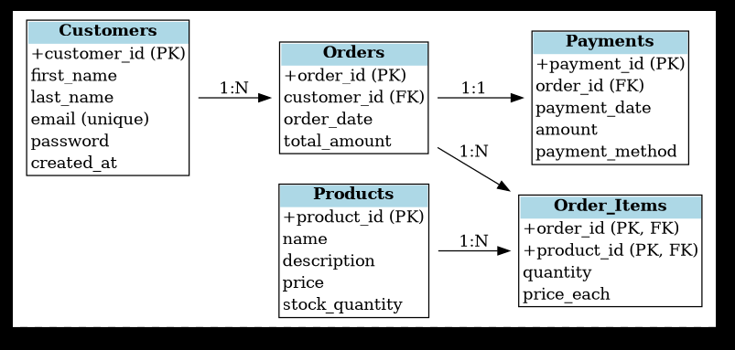
j

Part 3: Database Implementation

The third part of the project consists of implementing the previously designed database model using PostgreSQL. This includes schema creation, sample data insertion, relevant SQL queries, and clear documentation of the process.

Database Schema Creation
The schema was implemented in PostgreSQL using the following SQL script:
CREATE TABLE Customers (
CustomerID SERIAL PRIMARY KEY,
Name VARCHAR(100),
Email VARCHAR(100) UNIQUE,
Address TEXT,
Phone VARCHAR(20)
);

CREATE TABLE Products (
ProductID SERIAL PRIMARY KEY,
Name VARCHAR(100),
Description TEXT,
Price NUMERIC(10, 2),
Stock INTEGER
);

CREATE TABLE Orders (
OrderID SERIAL PRIMARY KEY,
CustomerID INTEGER REFERENCES Customers(CustomerID),
OrderDate DATE,
Status VARCHAR(50)
);

CREATE TABLE OrderItems (
OrderItemID SERIAL PRIMARY KEY,
OrderID INTEGER REFERENCES Orders(OrderID),
ProductID INTEGER REFERENCES Products(ProductID),
Quantity INTEGER,
Price NUMERIC(10, 2)
);

CREATE TABLE Payments (
PaymentID SERIAL PRIMARY KEY,
OrderID INTEGER REFERENCES Orders(OrderID),
PaymentDate DATE,
Amount NUMERIC(10, 2),
PaymentMethod VARCHAR(50)
);

2. Sample Data Insertion
Below is the SQL used to populate the tables with sample data:
-- Customers
INSERT INTO Customers (Name, Email, Address, Phone) VALUES
('Alice Dupont', 'alice@example.com', '12 rue des Fleurs, Paris', '0123456789'),
('Bob Martin', 'bob@example.com', '34 avenue des Champs, Lyon', '0987654321');

-- Products
INSERT INTO Products (Name, Description, Price, Stock) VALUES
('Clavier mécanique', 'Clavier RGB rétroéclairé', 79.99, 50),
('Souris sans fil', 'Souris ergonomique Bluetooth', 39.99, 100),
('Écran 24 pouces', 'Écran Full HD', 149.99, 30);

-- Orders
INSERT INTO Orders (CustomerID, OrderDate, Status) VALUES
(1, '2025-09-10', 'En cours'),
(2, '2025-09-11', 'Livrée');

-- Order Items
INSERT INTO OrderItems (OrderID, ProductID, Quantity, Price) VALUES
(1, 1, 1, 79.99),
(1, 2, 2, 39.99),
(2, 3, 1, 149.99);

-- Payments
INSERT INTO Payments (OrderID, PaymentDate, Amount, PaymentMethod) VALUES
(1, '2025-09-10', 159.97, 'Carte bancaire'),
(2, '2025-09-11', 149.99, 'PayPal');

and there is the result :

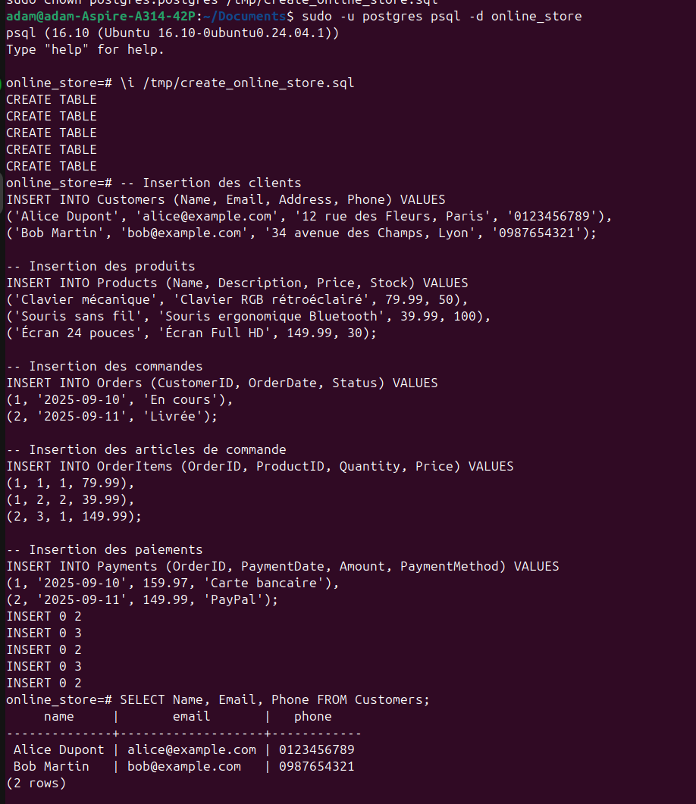
and :

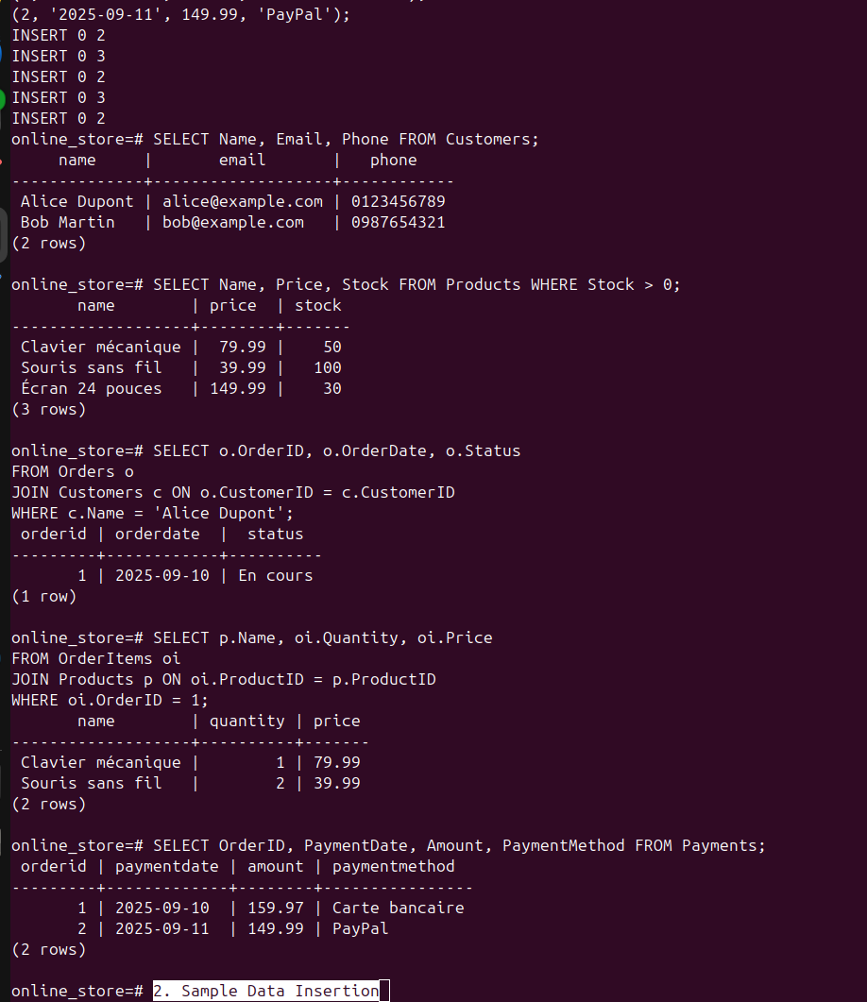
and this is the last test

Conclusion
This project provided a comprehensive overview of essential database concepts, including data modeling, implementation, and querying. Through the essay on SQL Injection, the Entity-Relationship Diagram of an online store, and a fully functional PostgreSQL implementation, the work demonstrates both theoretical understanding and practical database design skills.
The online store model includes all critical components—customers, products, orders, and payments—with proper normalization, foreign key relationships, and sample data. The SQL queries validate the database functionality and simulate realistic use cases.
Overall, this project highlights the importance of secure, well-structured databases in modern applications and reinforces the role of best practices in database development.

